New hydrogel can keep stem cells alive for heart repair
By Graham Templeton on September 28, 2015 at 9:30 am

Stem cells are great in theory; they’re the raw material from which every cell type in our bodies are made. We’re learning how to make them, and how to direct their action once made — they ought to be absolutely owning the headlines right now. The reason stem cells have not exploded in the past few years is simple: stem cells are fragile and fickle, and it’s difficult to get them to do what you want inside a real human body. In particular, stem cells have the nasty tendency to die when you inject them into something — but perhaps not for long. New research from Johns Hopkins University could let stem cells realize their potential in real-world situations.
The study used a hydrogel to protect and nourish stem cells bound for injection and differentiation into heart muscle cells. It used rats with damaged hearts and attempted to fix the damage by injecting their cell-laced hydrogel, “re-muscularizing” the area and fixing the characteristic damage of a heart attack. The hydrogel worked like a charm; when injected into the hearts of rats, the hydrogel saw about 73% of the stem cells survive, compared with just 12% survival while suspended in a normal injection fluid.
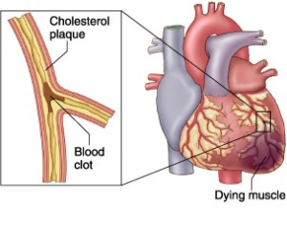Prior studies using stem cell injection have had to resort to specialized version of cells or cell components, or just injecting incredible numbers of the cells, but both of these approaches are costly, time consuming, and not particularly effective. This is currently the strategy with gene therapy as well, to flood an area with many nonspecific actors to wash out the importance of their individual incompetence, but that’s easier when you only need to make viral capsids; stem cells are whole cells, and it’s unlikely we’ll ever get to a point where it’s particularly quick or easy to grow them by the billions.
This hydrogel allows the cells to live and grow, installing themselves in the body and integrating healthily. Heart-damaged rats injected with hydrogel-loaded stem cells saw a 15% increase in pumping efficiency for the treated ventricle, compared with just 8% for regularly stem cell therapies. The team did not invent a treatment for this heart disease, but a booster pack that lets a preexisting treatment really kick into high gear. It can support both adult and embryonic stem cells, and if it’s not put inside a living being, the hydrogel can actually maintain 100% of the stem cells it contains.
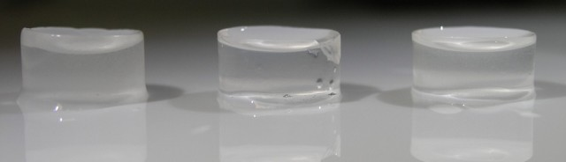Hydrogels are mostly water — just like you and me.
This comes soon after a separate team from Harvard University announced their porous hydrogel could also achieve huge increases in the effectiveness of stem cell therapies. That study looked a bone repair, but the idea is broadly similar: improve the effectiveness by increasing the number of stem cells that survive to enact their programming.
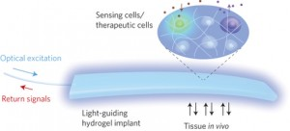
An experimental optical hydrogel implant.
Hydrogels are useful in biology because they’re much like us — made mostly of hydro. They’re intrinsically safe for use with biology, and biomedical engineers are even looking into using them as a bio-safe internal optical network. In fact, this study found that injecting just the hydrogel, with no stem cells at all, had a mild benefit all its own by seeming to promote blood vessel growth.
These are the sorts of breakthroughs that will allow the incredible but limited stem cell technologies of today to become the incredible, unlimited stem cell technologies of tomorrow.

